Introduction
Football squad selection is a complex decision-making process that requires balancing player performance, positional roles, and team structure. Traditionally, such decisions are made based on subjective judgment and experience. However, with the availability of structured player data, it is possible to adopt a data-driven approach to team selection.
This project focuses on building an optimal football squad using Structured Query Language (SQL) by analysing player data across multiple European nations. The dataset consists of player details such as position, experience, and nationality, along with performance statistics including goals, assists, and defensive contributions.
A 4-3-3 formation is used as the foundation for team selection, ensuring a balanced distribution of defenders, midfielders, and forwards. To evaluate players objectively, a position-based scoring model is developed, assigning different weights to performance metrics depending on the role of the player. This allows fair comparison across different positions and helps identify top-performing individuals.
By applying SQL techniques such as joins, aggregations, filtering, and window functions, the project systematically selects the best starting eleven and substitute players. The final outcome demonstrates how data analytics can enhance decision-making in sports by providing a structured and transparent method for squad selection.
Primary Objective
To build an optimal football squad consisting of 11 starting players and 5 substitutes using SQL, based on player performance, positional requirements, and experience levels.

Secondary Objectives
- To integrate and clean multiple datasets (player details and performance statistics) using SQL.
- To perform exploratory data analysis (EDA) in order to understand player distribution across positions and nations.
- To develop a position-based scoring model that evaluates players differently based on their roles (GK, DEF, MID, FWD).
- To apply SQL window functions and ranking techniques to identify top-performing players within each position.
- To construct a balanced 4-3-3 formation, ensuring proper allocation of defenders, midfielders, and forwards.
Dataset Description
The project utilizes two structured datasets containing information about football players:
1. Player Details Dataset (player_details)
This dataset contains general information about players, including:
- player_id – Unique identifier for each player (Primary Key)
- player_name – Name of the player
- position – Player role (GK, DEF, MID, FWD)
- nation – Player nationality represented using 3-letter codes (e.g., ENG, ESP)
- experience – Number of years of professional experience

2. Player Statistics Dataset (player_stats)
This dataset contains performance-related metrics, including:
- player_id – Unique identifier used to link with player details
- goals – Number of goals scored
- assists – Number of assists provided
- tackles – Defensive contributions made by the player

Exploratory Data Analysis (EDA)
The purpose of Exploratory Data Analysis (EDA) is to understand the structure, distribution, and key characteristics of the dataset before applying the scoring model and selection logic. This step helps in identifying patterns and ensuring that the data is suitable for decision-making.
1. Player Distribution by Position
The dataset categorizes players into four primary roles: Goalkeeper (GK), Defender (DEF), Midfielder (MID), and Forward (FWD).
Analysis of player distribution shows whether sufficient players are available in each position to construct a balanced team.

SQL QUERY - select position, count(*) as count_of_players
from filtered_players
group by position
order by count(*) desc
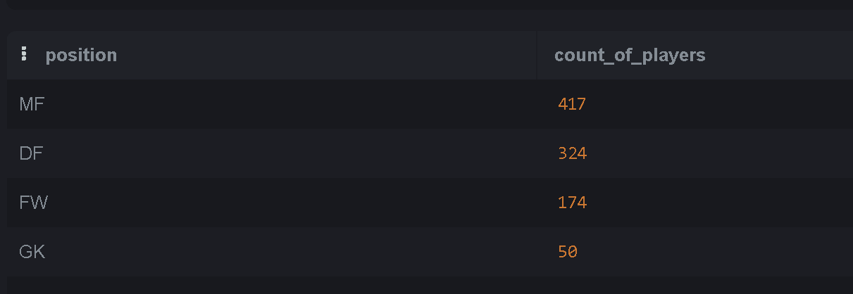

Insight:
- Defenders and midfielders typically form the largest share of players
- Goalkeepers are fewer in number compared to outfield players

2. Player Distribution by Nation
Players are distributed across multiple European nations such as ENG, ESP, GER, FRA, and others.
SQL QUERY - select nations, count(*) as count_of_players
from filtered_players
group by nations
order by count(*) desc
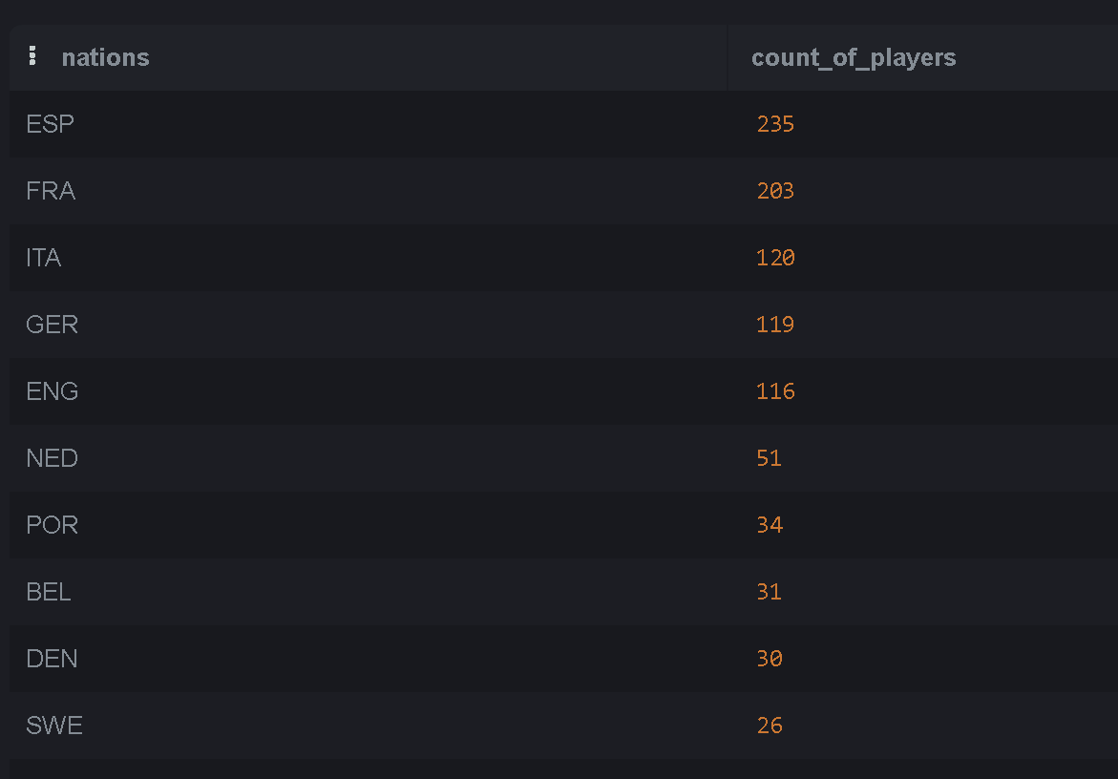

3. Performance Analysis
Player performance was evaluated using key metrics:
- Goals (attacking contribution)
- Assists (playmaking ability)
- Tackles (defensive contribution)
SQL QUERY - select position, sum(goals) as total_goals, sum(assists) as totals_assists , COALESCE(sum(saves),0) as total_saves
from filtered_players
group by position
order by 2 desc, 3 desc, 4 desc

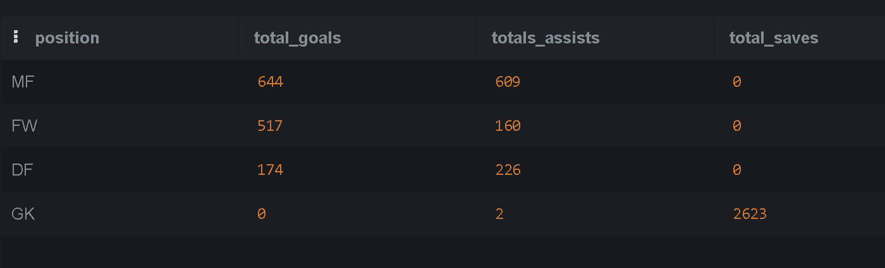

4. Top Performers Identification
Top-performing players were identified based on individual metrics such as:
- Highest goal scorers
- Highest assist providers
- Players with strong defensive records

SQL QUERY - SELECT * FROM (SELECT 'Top Goal Scorer' AS category, player, goals AS value
FROM filtered_players
ORDER BY goals DESC
LIMIT 1)

UNION ALL

SELECT * FROM (SELECT 'Top Assist Provider' AS category, player, assists AS value
FROM filtered_players
ORDER BY assists DESC
LIMIT 1)

UNION ALL

SELECT * FROM (
SELECT 'Top Saves (GK)' AS category, player, saves AS value
FROM filtered_players
WHERE position = 'GK'
ORDER BY saves DESC
LIMIT 1);
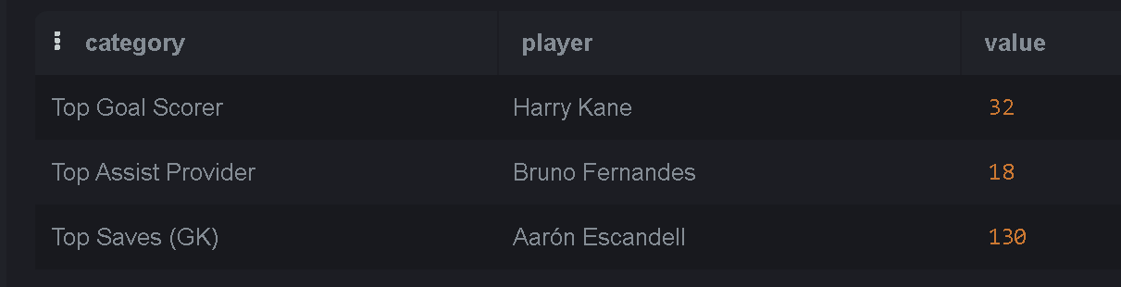

Scoring Model
Purpose
The purpose of the scoring model is to evaluate players objectively by assigning a numerical score based on their performance metrics. Since different positions contribute differently on the field, a position-based weighted scoring system is used.
Approach
Players were categorized into four roles:
- Goalkeeper (GK)
- Defender (DEF)
- Midfielder (MID)
- Forward (FWD)
Each role was evaluated using different weights based on their responsibilities.
Scoring Logic
The following weighted formulas were applied:
- Forwards (FWD):
Focus on attacking contribution
→ Goals (high weight), Assists
- Midfielders (MID):
Balanced contribution
→ Goals, Assists
- Defenders (DEF):
Defensive contribution
→ fouls, Assists
- Goalkeepers (GK):
Defensive reliability
→ Saves (or fallback metric like tackles if saves unavailable)

SQL query - CREATE TABLE player_scores AS
SELECT player_id, player,
position,
nations,
min as experience,
CASE
WHEN position = 'FW'
THEN (goals * 5 + assists * 3- fouls * 2)
WHEN position = 'MF'
THEN (goals * 3 + assists * 4 - fouls * 0.25)
WHEN position = 'DF'
THEN (assists * 2 – red_cards *1)
WHEN position = 'GK'
THEN (saves * 5 -fouls*2)
END AS score
FROM filtered_players;

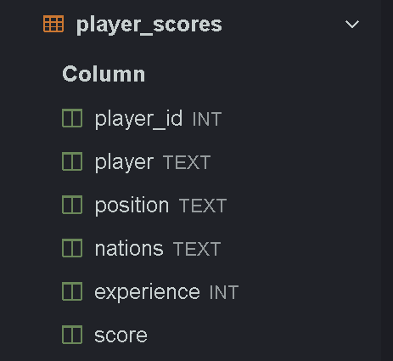

Team Selection Logic (4-3-3 Formation)

Purpose
The objective of this stage is to select an optimal squad consisting of 11 starting players and 5 substitutes using the performance scores generated in the previous step. The selection follows a 4-3-3 formation, ensuring a balanced team structure.

Formation Strategy
The team is structured as follows:
- Goalkeeper (GK): 1
- Defenders (DEF): 4
- Midfielders (MID): 3
- Forwards (FWD): 3
Additionally, 5 substitute players are selected to provide depth and flexibility.

Selection Approach
Players are ranked within each position using SQL window functions. The top-ranked players are selected based on their performance score, ensuring:
- Best players per position are chosen
- No duplication of players
- Balanced team composition
SQL QUERY -SELECT player, position, score,
CASE
WHEN position = 'GK' AND rnk = 1 THEN 'Starting XI'
WHEN position = 'DF' AND rnk <= 4 THEN 'Starting XI'
WHEN position = 'MF' AND rnk <= 3 THEN 'Starting XI'
WHEN position = 'FW' AND rnk <= 3 THEN 'Starting XI'

WHEN position = 'GK' AND rnk = 2 THEN 'Substitute'
WHEN position = 'DF' AND rnk BETWEEN 5 AND 6 THEN 'Substitute'
WHEN position = 'MF' AND rnk = 4 THEN 'Substitute'
WHEN position = 'FW' AND rnk BETWEEN 4 AND 5 THEN 'Substitute'
END AS squad_role
FROM (SELECT *,
ROW_NUMBER() OVER (PARTITION BY position ORDER BY score DESC) AS rnkFROM player_scores
) t
WHERE
(position = 'GK' AND rnk <= 2)
OR
(position = 'DF' AND rnk <= 6)
OR
(position = 'MF' AND rnk <= 4)
OR
(position = 'FW' AND rnk <= 5);
